---Problem Set 4 – Multiple Regression Part I

Question 1 (5 points)
Please access the Real Estate Data. These data are from Kaggle, and no license agreement was listed as known. Latitude, longitude pairs within the data suggest they correspond to housing prices in New Taipei City, in the Xindian District, Taiwan. This led to certain (possibly incorrect) assumptions being made about the units for the variables. The dataset consists of:
- Age of House (years)
- Distance to Nearest MRT Station (meters)
- Number of Convenience Stores (within a kilometer)
- Latitude
- Longitude
- House Price Per Unit Area (Taiwanese dollars)
JMP's Fit Y by X was used to create the following scatterplot of House Price Per Unit Area versus Distance to Nearest MRT Station and three curves were fit to the plot.
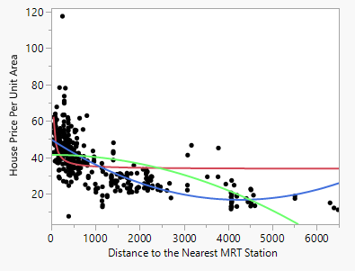
Please identify the curves. The possibilities are:
- A reciprocal function of the general form y = a*(1/x), where x = Distance to Nearest MRT Station and a is some constant.
- A parabola with its vertex at x=0 and y = 42 -- specific form (y-42) = - x².
- A parabola with its vertex at x=3800 and y=20 -- specific form (y-20) = (x-3800)².
Only one of the answers below is reasonable. Place an “X” in the box to the immediate left of your chosen answer.
Problem 1: Solution Choices
 | Red = B, Green = A, Blue = C
X | Red = A, Green = B, Blue = C
 | Red = C, Green = B, Blue = A
 | Red = B, Green = C, Blue = A

Question 2 (5 points)
Please access the Real Estate Data. These data are from Kaggle, and no license agreement was listed as known. Latitude, longitude pairs within the data suggest they correspond to housing prices in New Taipei City, in the Xindian District, Taiwan. This led to certain (possibly wrong) assumptions being made about the units for the variables. The dataset consists of:
- Age of House (years)
- Distance to Nearest MRT Station (meters)
- Number of Convenience Stores (within a kilometer)
- Latitude
- Longitude
- House Price Per Unit Area (Taiwanese dollars)
Use JMP to fit the following models. We’ve abbreviated the variable names so the equations will fit this document’s formatting.
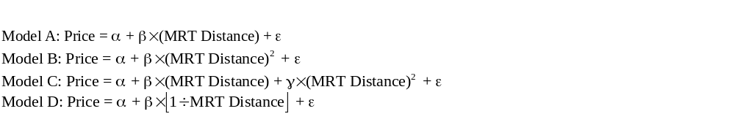
Order the models based on their coefficients of determination from largest to smallest. Only one answer is reasonable. Place an “X” in the box to the immediate left of your chosen answer.

Problem 2: Solution Choices
x | C > A > B > D
 | C > B > D > A
 | B > D > C > A
 | A > B > C > D

Problem 3 (20 points)
Please access the Real Estate Data. These data are from Kaggle, and no license agreement was listed as known. Latitude, longitude pairs within the data suggest they correspond to housing prices in New Taipei City, in the Xindian District, Taiwan. This led to certain (possibly wrong) assumptions being made about the units for the variables. The dataset consists of:
- Age of House (years)
- Distance to Nearest MRT Station (meters)
- Number of Convenience Stores (within a kilometer)
- Latitude
- Longitude
- House Price Per Unit Area (Taiwanese dollars)
Please answer each of the following questions. So that your answers remain focused, you are to include ONLY the output that is requested (else, your earned credit will be reduced).
- (5 points) Use JMP to fit House Price Per Unit Area to the other five variables. Do not use any transformations and do not remove any observations. Copy and paste the Summary of Fit table in the space below.

RSquare | 0.571162
RSquare Adj | 0.565906
Root Mean Square Error | 8.964741
Mean of Response | 37.98019
Observations (or Sum Wgts) | 414

- (5 points) Refer to part a. In two sentences or less, provide a statement about the model fit, in the language of the problem.
Approximately 57.12% of the variation in House Price per unit Area is explained by age of house, distance to nearest MRT station, number of convenience stores, latitude, and longitude
- (5 points) Use JMP to fit House Price Per Unit Area to the other five variables. Do not use any transformations and do not remove any observations. Copy and paste the Parameter Estimates table in the answer space below.

Term | Estimate | Std Error | t Ratio | Prob>|t|
Intercept | -4945.595 | 6211.157 | -0.80 | 0.4264
Age of House | -0.268917 | 0.038996 | -6.90 | <.0001*
Distance to the Nearest MRT Station | -0.004259 | 0.000723 | -5.89 | <.0001*
Number of Convenience Stores | 1.1630205 | 0.190221 | 6.11 | <.0001*
Latitude | 237.76719 | 44.94802 | 5.29 | <.0001*
Longitude | -7.805453 | 49.14891 | -0.16 | 0.8739

- (5 points) Refer to part c. In two sentences or less, provide an interpretation of the estimated slope for Longitude, in the language of the problem.
If the age of the house, distance to the nearest MRT station, number of convenience stores, and latitude are constant, a one-degree increase in longitude is associated with an estimated 7.81decrease in house price per unit area.

Problem 4 (20 points)
Please access the Real Estate Data. These data are from Kaggle, and no license agreement was listed as known. Latitude, longitude pairs within the data suggest they correspond to housing prices in New Taipei City, in the Xindian District, Taiwan. This led to certain (possibly wrong) assumptions being made about the units for the variables. The dataset consists of:
- Age of House (years)
- Distance to Nearest MRT Station (meters)
- Number of Convenience Stores (within a kilometer)
- Latitude
- Longitude
- House Price Per Unit Area (Taiwanese dollars)
Please answer each of the following questions. So that your answers remain focused, you are to include ONLY the output or answers that are requested (else, your earned credit will be reduced).

- (5 points) Please follow these steps to create a map of the area under study in New Taipei City. Once you have created the map, copy and paste it into the space following the list of steps. Keep the Graph Builder window open since you will be customizing it in part b.

Steps (from AI Google)
- Open Graph Builder: Go to Graph > Graph Builder.
- Add Latitude and Longitude: Drag the column containing latitude values to the Y-axis and the column containing longitude values to the X-axis.
- Remove Smoother: A smoother (curve) will be added to the plot by default. Remove it by right-clicking on the smoothing icon on the upper left of the Graph Builder window.
- Add Background Map: Right-click on the plot area and select "Graph" then "Background Map".
- Choose Map Type: Use Street Map Service (radio buttons) and Mapbox Streets (URL dropdown) as your options.
- Copy the Graph: Right-click anywhere on your graph, choose Edit, then Copy Graph.

PASTE GRAPH HERE

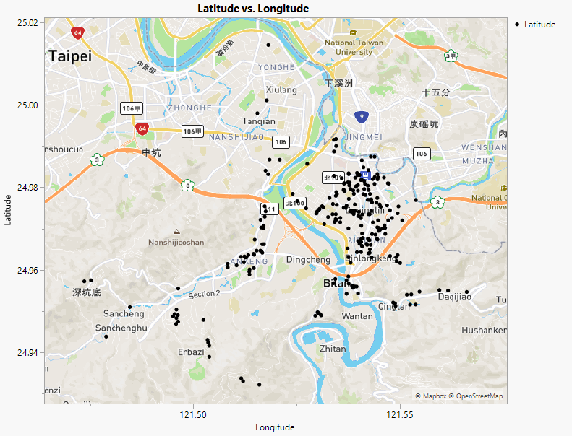
- (5 points) Return to Graph Builder from part a. Please follow these steps to create a “heat map” superimposed on your current map. This heat map will simply use colors to display the gradient of house prices (per unit area) in the area under study. Once you have created the map, copy and paste it into the space following the list of steps.

Steps (from Trial and Error)
- Back in Graph Builder: Grab “House Price Per Unit Area” and drag it to the Color box on the right-hand side of the Graph Builder window.
- Customize the Gradient Part 1: Right-click on the gradient color bar, choose Gradient.
- Customize the Gradient Part 2: On the Gradient Settings window click on the Color Theme. Choose Black Body. That one is three from the bottom under the Sequential list on our version of JMP. This just makes it easier to see where the higher prices houses are.
- Click OK: On the Color Theme window and then the Gradient Settings window.
- Copy the Graph: Right-click anywhere on your graph, choose Edit, then Copy Graph.

PASTE GRAPH HERE
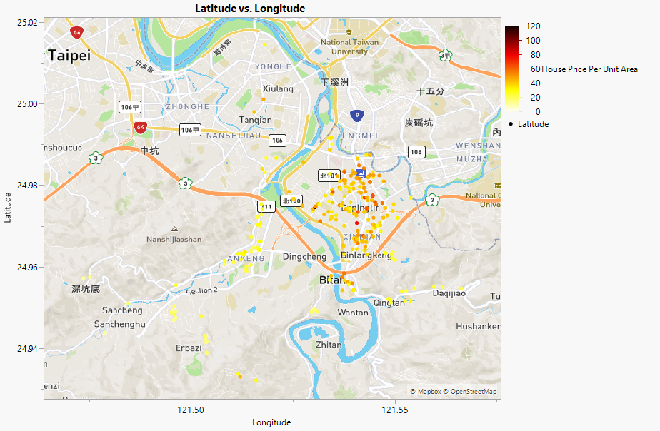
- (5 points) Refer to your graph in part b. In no more than two sentences, explain where on that map the more expensive properties are.

The more expensive properties are generally concentrated in the central to northeastern portion of the study area. Lower-priced properties are more common toward the outer portions of the mapped area.

- (5 points) Refer to your answers to part c of this problem and part d of Problem 3. In two sentences or less, explain if they are consistent or not.

The results are not consistent. The map shows that higher-priced properties tend to occur farther east, while the negative Longitude coefficient from Problem 3 indicates that house price is estimated to decrease as longitude increases.

